IRMA
The program inflation-resistant-stablecoin/irma is the "IRMA Market Maker", “Inflation Oracle”, and “Off-chain Worker” in the figure below. For every Solana slot (or block), it retrieves all market events and processes each one using the methods in the pricing.rs module. It then uses results from the pricing methods to set the price and replaces the market orders.
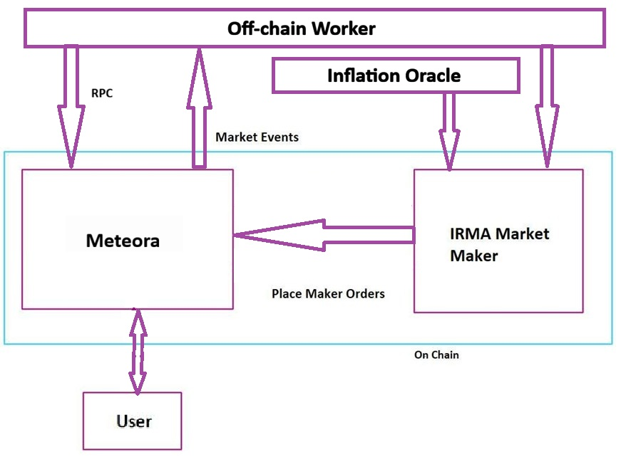
There are only two limit orders that the IRMA program sets:
- Mint price in terms of each reserve stablecoin
- Redemption price in terms of each reserve stablecoin
See visualization below.
In the beginning there will be no redemp on prices (because there are no reserves yet). If there are six reserve stablecoins, there will be six mint prices (six sell limit orders) and six redemption prices (six buy limit orders).
Note also that, in the beginning, when there is some reserve backing but before inflation starts, mint price = redemption price. Arbitrageurs can’t insert prices between mint and redemption prices and so there is no order book like shown below.

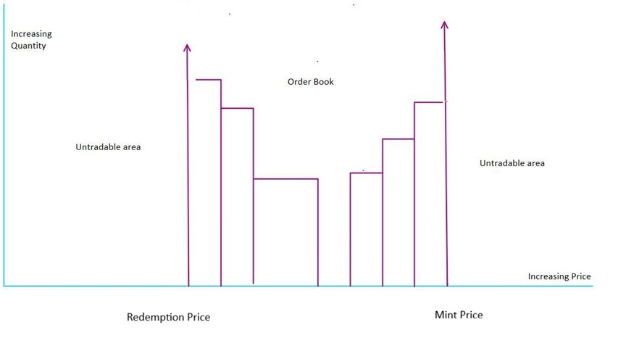

Redemption Price = (Reserve Backing Total Divided by IRMA in circulation)
Mint Price = (depends on inflation)

